Activities
"An Activity is an application component that provides a screen with which users can interact in order to do something, such as dial the phone, take a photo, send an email, or view a map. Each activity is given a window in which to draw its user interface. The window typically fills the screen, but may be smaller than the screen and float on top of other windows."

"An application usually consists of multiple activities that are loosely bound to each other. Typically, one activity in an application is specified as the "main" activity, which is presented to the user when launching the application for the first time. Each activity can then start another activity in order to perform different actions. Each time a new activity starts, the previous activity is stopped, but the system preserves the activity in a stack (the "back stack"). When a new activity starts, it is pushed onto the back stack and takes user focus. The back stack abides to the basic "last in, first out" stack mechanism, so, when the user is done with the current activity and presses the Back button, it is popped from the stack (and destroyed) and the previous activity resumes."

Making an activity
To create an activity, you must create a subclass of Activity (or an existing subclass of it). Eg:
public class MainActivity extends AppCompatActivity {
}
In your subclass, you need to implement callback methods that the system calls when the activity transitions between various states of its lifecycle, such as when the activity is being created, stopped, resumed, or destroyed. There is only one method that you absolutely have to call, onCreate().
onCreate(): You must implement this method. The system calls this when creating your activity. Within your implementation, you should initialize the essential components of your activity. Most importantly, this is where you must call setContentView() to define the layout for the activity's user interface. This is the link to the xml file.
Eg:

public class ChatActivity extends AppCompatActivity {
@Override
protected void onCreate(Bundle savedInstanceState) {
super.onCreate(savedInstanceState);
setContentView(R.layout.activity_chat);
}
}
Also inportant is the call to Super.onCreate, this will call any neccesary components of the onCreate function that is being overritten. So in reality you aren't really overwriting the onCreate method so much as adding to it, unless you leave off supe.onCreate. Which you can do, but then the onus is one you to impliment dfiferent versions of all the stuff onCreate already does. Simply leaving it off without replacing these functions will pretty much break onCreate and the activity. This customization isn't very common though and rarely worth doing.

The second thing an activity needs is an xml layout. This can be literally any normal valid activity layout, such a simple linear layout xml file. Eg:

Here is an example of a typical XML layout for an activity:

<?xml version="1.0" encoding="utf-8"?>
<LinearLayout xmlns:android="http://schemas.android.com/apk/res/android"
xmlns:tools="http://schemas.android.com/tools"
xmlns:app="http://schemas.android.com/apk/res-auto"
android:layout_width="match_parent"
android:layout_height="match_parent"
android:orientation="vertical"
tools:context="com.example.android.sunshine.app.MainActivity"
android:id="@+id/linear_layout">
</LinearLayout>
However it is common (espically in the Main activity, see below) to seperate the content xml from the main xml file, like this:

<?xml version="1.0" encoding="utf-8"?>
<android.support.design.widget.CoordinatorLayout
xmlns:android="http://schemas.android.com/apk/res/android"
xmlns:app="http://schemas.android.com/apk/res-auto"
xmlns:tools="http://schemas.android.com/tools" android:layout_width="match_parent"
android:layout_height="match_parent" android:fitsSystemWindows="true"
tools:context=".MainActivity">
<include layout="@layout/content_main" />
</android.support.design.widget.CoordinatorLayout>
With content_main.xml being a seperate file with an actual layout eg. It will contain the textview, edittext, buttons etc. Why are the two seperate (they don't have to be, you can replace <include layout="@layout/content_main" /> with the actual xml liens of content_main)? This is what the android developer website has to say about that is created on default:

"activity_main:
This XML layout file is for the activity you added when you created the project with Android Studio. Following the New Project workflow, Android Studio presents this file with both a text view and a preview of the screen UI. The file contains some default interface elements from the material design library, including the app bar and a floating action button. It also includes a separate layout file with the main content
content_main:
This XML layout file resides in activity_my.xml (activity_main) , and contains some settings and Textview(other) element."

Hmmm. Perhaps more helpfully is this comment off stack overflow:

"So the activity_main.xml determines how the Activity (MainActivity in this case) should look. It determines its design.The content_main.xml is a part of the activity_main.xml."

This seems to me like fragments in miniature, seperating the overall design and tabviews etc from the actual content of the opening page. This is especially relavent if you aren't using fragments, but if you do use a fragment in your main activity then that would be more appropriate.

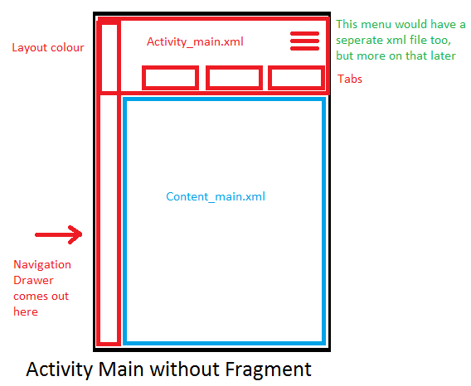
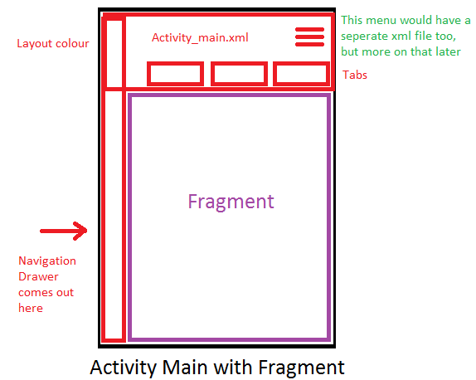
The main difference between these two is that our activity class will be able to refer to all the UI items in Content_main.xml whilst with the fragment the fragment will have its own class.

XMLS Tags
What is going on with those xmlns tags? These tags are needed to tell the compiler reading the xml what namespaces are being used. The Http addresses are URI's rather than actual URLs (URI stands for universal resource identifier). It uses the HTTPS format but isn't for use on the world wide web, and your code won't need web access for android to knwo what's going on. URLs are actually a special form of URI.

In the above you can the android, app and tools namespaces being used. Thus when a line starts with android: or tools: android will know what to make of them. Without he URI's referenced in theroot layout of the xml file the various lines refereing to layout attributes (like android layout_height etc) won't work.

Main Activity

Android will generate a default Main acitivty for you, with onCreate and a few other items already set up.

Creating additional activities can be done by right clikcing on the folder on the left where they are all stored, and adding a new class. It is also possible to add a new class, but this generates a lot of extra todo, comments, routines and worst of all strange dependancies that aren't yours and often have to be weeded out, so currently I find just manually creating your own from scratch is best as long as you know what you are going.

Defining the Main activity

Main activity will be what starts when the app first starts. You can define which activity to use as the main activity in the Android manifest file, AndroidManifest.xml which is at the root of your project directory.

<activity android:name=".MainActivity" android:label="@string/app_name">
<intent-filter>
<action android:name="android.intent.action.MAIN" />
<category android:name="android.intent.category.LAUNCHER" />
</intent-filter>
</activity>

From your main activity though other apps will have to be called, see below.

The Activity Lifecycle
https://developer.android.com/training/basics/activity-lifecycle/index.html

"Unlike other programming paradigms in which apps are launched with a main() method, the Android system initiates code in an Activity instance by invoking specific callback methods that correspond to specific stages of its lifecycle. There is a sequence of callback methods that start up an activity and a sequence of callback methods that tear down an activity."

OK clear enough in terms of the sequencing, but what are callback methods? Callback methods are functions which are passed to other functions, telling them to excecute (or 'callback') the function after a certain event continues. When the event occurs an interrupt will happen* and that function will be called. Button callback methods are agood example of this, we write a callback method in our code and then pass this to the button telling it to call it when an onclick event handles. Our code can then move on and do other things without waiting around, the button will call and excecute our code when the event occurs.

In this instance these methods are probably passed to the main android operating system, they'll be calling them as it moves the activity though its lifecycle

*probably not the exactly correct programming term outside of microcontrollers but that's the basic gist of it.

"During the life of an activity, the system calls a core set of lifecycle methods in a sequence similar to a step pyramid. That is, each stage of the activity lifecycle is a separate step on the pyramid. As the system creates a new activity instance, each callback method moves the activity state one step toward the top. The top of the pyramid is the point at which the activity is running in the foreground and the user can interact with it.

As the user begins to leave the activity, the system calls other methods that move the activity state back down the pyramid in order to dismantle the activity. In some cases, the activity will move only part way down the pyramid and wait (such as when the user switches to another app), from which point the activity can move back to the top (if the user returns to the activity) and resume where the user left off."

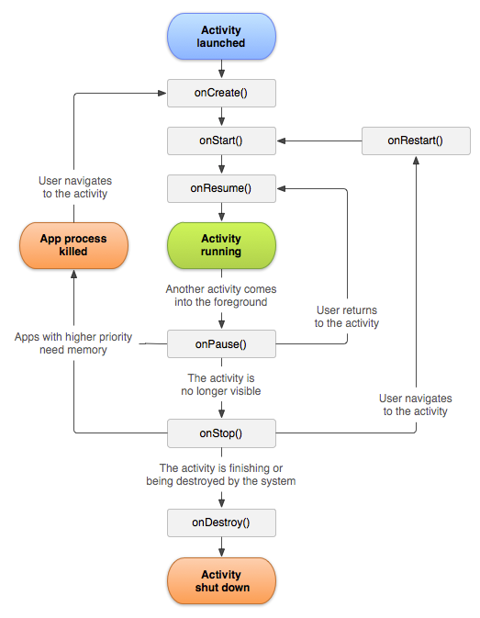
Resumed: In this state, the activity is in the foreground and the user can interact with it. (Also sometimes referred to as the "running" state.)

Paused: In this state, the activity is partially obscured by another activity—the other activity that's in the foreground is semi-transparent or doesn't cover the entire screen. The paused activity does not receive user input and cannot execute any code.

Stopped: In this state, the activity is completely hidden and not visible to the user; it is considered to be in the background. While stopped, the activity instance and all its state information such as member variables is retained, but it cannot execute any code.

The other states (Created and Started) are transient and the system quickly moves from them to the next state by calling the next lifecycle callback method. That is, after the system calls onCreate(), it quickly calls onStart(), which is quickly followed by onResume().

Created: already been over this, this is the only state in which its method onCreate has to be called. Should define the user interface and possibly instantiate some class-scope variables eg. mTextView = (TextView) findViewById(R.id.text_message);

Started: Called just before the activity becomes visible to the user.

Resume: Called just before the activity starts interacting with the user. At this point the activity is at the top of the activity stack, with user input going to it.

I need to come back with conrete examples for onStart and onREsume here. Hopefully I'll find more use for them in the future. Curently I'm jsut throwing most of the setup in the onCreate method, see below:

Interacting with the user inteface from your Activity
To interact with the various layout objects created when you set your contentview (eg the activities associated xml file) you'll need to define varibales to store each of these objects, so an object for a textview, an object for an imageview.

One standard seen in Google examples is to make these variables global within the Activity class and then set them in the onCreate function. Eg

TextView mTextView
@Override
protected void onCreate(Bundle savedInstanceState) {
super.onCreate(savedInstanceState);
setContentView(R.layout.activity_chat);
mTextView = (TextView) findViewById(R.id.text_message);
}

Make sure you are only calling these variable initializations after setting the contentview otherwise findViewByID won't know where to look.

Creating New Activities
Activities are started using intents. You can start another activity by calling startActivity(), passing it an Intent that describes the activity you want to start. The intent specifies either the exact activity you want to start or describes the type of action you want to perform (and the system selects the appropriate activity for you, which can even be from a different application).

Intent intent = new Intent(this, SignInActivity.class);
startActivity(intent);

Passing simple variables to a new activity
An intent can also carry small amounts of data to be used by the activity that is started:

Intent intent= new Intent(this, LineActivity.class);
intent.putExtra("Passed String",passString);
startActivity(intent);
The variables that can be passed have to be primitives or of type String.
Starting an activity for a result
You can also start an activity expectign a specific result in return. I haven't used this yet, but how to do it is explained here: https://developer.android.com/guide/components/activities.html

This basically makes an activity act as a function.

Passing class instances to a new activity
If you are trying to pass a instance of a user defined class, it will have to be parcelable, which probably deserves its own word document. Meanwhile simply use this unless you're paranoid about someone else copying you code: http://www.parcelabler.com/

Serializable is a standard Java interface. You simply mark a class Serializable by implementing the interface, and Java will automatically serialize it in certain situations. Serialization is the conversion of an object to a series of bytes, so that the object can be easily saved to persistent storage or streamed across a communication link. The byte stream can then be deserialized - converted into a replica of the original object.
Parcelable is an Android specific interface where you implement the serialization yourself. It was created to be far more efficient that Serializable, and to get around some problems with the default Java serialization scheme.

Fragments
What is a fragment? Fragments are basically small sub-activities. They allow for greater modualtity of design when making the layout of your android app, which is useful considering the number of screen sizes available.

"A Fragment represents a behavior or a portion of user interface in an Activity. You can combine multiple fragments in a single activity to build a multi-pane UI and reuse a fragment in multiple activities. You can think of a fragment as a modular section of an activity, which has its own lifecycle, receives its own input events, and which you can add or remove while the activity is running (sort of like a "sub activity" that you can reuse in different activities). "

Making an fragment
Fragments have a lifecycle much like an activity. However they have a few more functions they have to create. Usually, you should implement at least the following lifecycle methods, but only onCreateView is absolutely vital:
onCreate()
The system calls this when creating the fragment. Within your implementation, you should initialize essential components of the fragment that you want to retain when the fragment is paused or stopped, then resumed.
onCreateView()
The system calls this when it's time for the fragment to draw its user interface for the first time. To draw a UI for your fragment, you must return a View from this method that is the root of your fragment's layout. You can return null if the fragment does not provide a UI.
onPause()
The system calls this method as the first indication that the user is leaving the fragment (though it does not always mean the fragment is being destroyed). This is usually where you should commit any changes that should be persisted beyond the current user session (because the user might not come back).

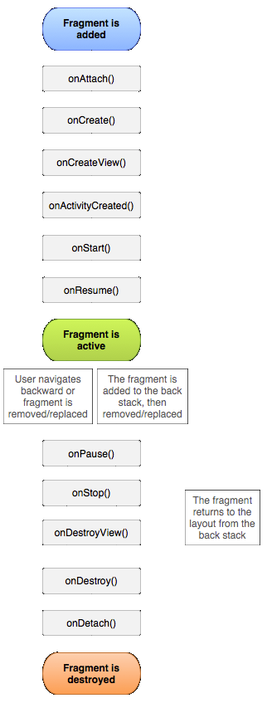
The key difference here seems to be the addition of onCreateView seperate to onCreate. I don't know quite why this is, but onCreateView returns a View object, so I suspect this is because fragments have to slot into an already existing UI interface of its parents fragment.

(worth noting here that fragments can be created without UIs, but I haven't seen a really good example where a fragment without a UI is needed... Aparently these will also need onCreateView?)

Thus here is an example default fragment:

import android.os.Bundle;
import android.support.v4.app.Fragment;
import android.view.LayoutInflater;
import android.view.ViewGroup;
public class ArticleFragment extends Fragment {
View rootView;
@Override
public View onCreateView(LayoutInflater inflater, ViewGroup container,
Bundle savedInstanceState) {
// Inflate the layout for this fragment
rootView = inflater.inflate(R.layout.article_view , container, false);
//Code goes here
return rootView;

}
}

Important to note here, the last thing the Fragment must do is return the rootview, but it is generally better to have a seperate rootView variable inflated first thing in the on create so it can be refered to in the onCreate. Then return that view.

Adding a Fragment to an Activity
Unlike when an activity makes another activity, fragments have to be made by activites (fragments can't contain or make other fragments). Also unlike activities, they won't have a life of their own, they have to belong to a parent activity. Fragments can call and create other actvities though, just like activities themsleves can and use the exact same system of intents to do so.
This parent activity will have to be subtyped as a FragmentActivity (aparently although I get the feeling I might have made a compatActivity before with fragments. Hmm) Aha here is the details mybad:

Note: FragmentActivity is a special activity provided in the Support Library to handle fragments on system versions older than API level 11. If the lowest system version you support is API level 11 or higher, then you can use a regular Activity.

So hopefully this wont't be an issue moving forwards, but something to keep in mind.

There are two ways of adding fragments to the activity, dynamically or statically.

Statically adding a Fragment
Add a fragment to the main activities xml like so:
<LinearLayout xmlns:android="http://schemas.android.com/apk/res/android"
android:orientation="horizontal"
android:layout_width="fill_parent"
android:layout_height="fill_parent">
<fragment android:name="com.example.android.fragments.HeadlinesFragment"
android:id="@+id/headlines_fragment"
android:layout_weight="1"
android:layout_width="0dp"
android:layout_height="match_parent" />
</LinearLayout>

The key thing to note here is the android:name field of this fragment element. This tells the compiler what fragment this is and will connect the fragment class you've written in Java to this xml element. The activity will initialize the fragment when it inflates its layout.

Dynamically adding a Fragment (Add a Fragment to an Activity at Runtime)
Adding fragments dynamically has the main advantage of allowing you to swop out fragment elements in the activity during excecution.

"To perform a transaction such as add or remove a fragment, you must use the FragmentManager to create a FragmentTransaction, which provides APIs to add, remove, replace, and perform other fragment transactions. "

To do this add a framelayout in your activity layout file where you want the fragment to be:

<FrameLayout xmlns:android="http://schemas.android.com/apk/res/android"
android:id="@+id/fragment_container"
android:layout_width="match_parent"
android:layout_height="match_parent" />

"Inside your activity, call getSupportFragmentManager() to get a FragmentManager using the Support Library APIs. Then call beginTransaction() to create a FragmentTransaction and call add() to add a fragment.

You can perform multiple fragment transaction for the activity using the same FragmentTransaction. When you're ready to make the changes, you must call commit()."

import android.os.Bundle;
import android.support.v4.app.FragmentActivity;
public class MainActivity extends FragmentActivity {
@Override
public void onCreate(Bundle savedInstanceState) {
super.onCreate(savedInstanceState);
setContentView(R.layout.news_articles);
// Check that the activity is using the layout version with
// the fragment_container FrameLayout
if (findViewById(R.id.fragment_container) != null) {
// However, if we're being restored from a previous state,
// then we don't need to do anything and should return or else
// we could end up with overlapping fragments.
if (savedInstanceState != null) {
return;
}
// Create a new Fragment to be placed in the activity layout
HeadlinesFragment firstFragment = new HeadlinesFragment();
// In case this activity was started with special instructions from an
// Intent, pass the Intent's extras to the fragment as arguments
firstFragment.setArguments(getIntent().getExtras());
// Add the fragment to the 'fragment_container' FrameLayout
getSupportFragmentManager().beginTransaction()
.add(R.id.fragment_container, firstFragment).commit();
}
}
}

When you want to replace the fragment:

FragmentTransaction transaction = getSupportFragmentManager().beginTransaction();
// Replace whatever is in the fragment_container view with this fragment,
// and add the transaction to the back stack so the user can navigate back
transaction.replace(R.id.fragment_container, newFragment);
transaction.addToBackStack(null);
// Commit the transaction
transaction.commit();

Activity communicating with one of its Fragments

Fragment Communicating with its Activity

There are two basic ways of doing this

Starting an Activity from inside a fragment

Make sure that the intent is passed the fragments parent activity as its first parameter don't use the "this" keyword like you would if launching the activity from another activity. Eg:

Intent intent = new Intent(getActivity(), NewActivity.class);
startActivity(intent);

